Lecture 13

**ApacheServer-with-2Containers**

* Host a website other then its default path it is called **DocumentRoot** in Apache i.e /var/www/html
* Task
* We have hosted 1 page (khuramsaggu.com)
* Now host 2nd page (alnafi.com) in a different DocumentRoot other then default path of Apache.
* VirtualHost is configured 🡪 the first container is also called **“Master Container”**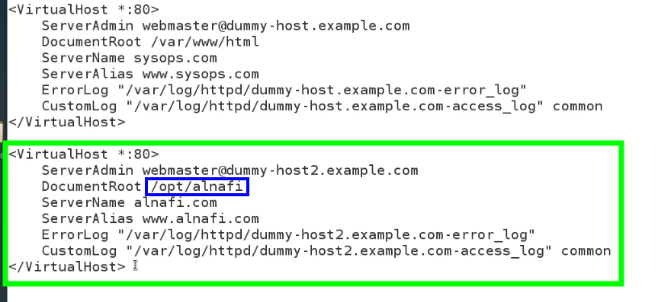
* Point to remember!!!
  + If there is a problem in Container No. 2, the web page configured in Container No 1 will be displayed.
  + And if there is a problem in Container No. 1, the default webpage of Apache server will be displayed.
* How the web page is opened 🡪 process
  + Browser throws the request to /etc/hosts 🡪 the website name is found
  + The browser then sends the request to post No. 80 of the server with IP and in IP header “sysops.com” of whatever its website name is.
  + Port No. 80 send it to Apache VH-conf file
  + Here it searched the containers.
  + In the container which have specific webserver name – matches
  + After matching, it goes to DocumentRoot to open the specific webpage.
* The 2nd webpage is configured in VH-conf file in 2nd container
* The IP is added in /etc/hosts/
* While the page is tried to open 🡪 default web page of Apache is open instead of required web page.
* 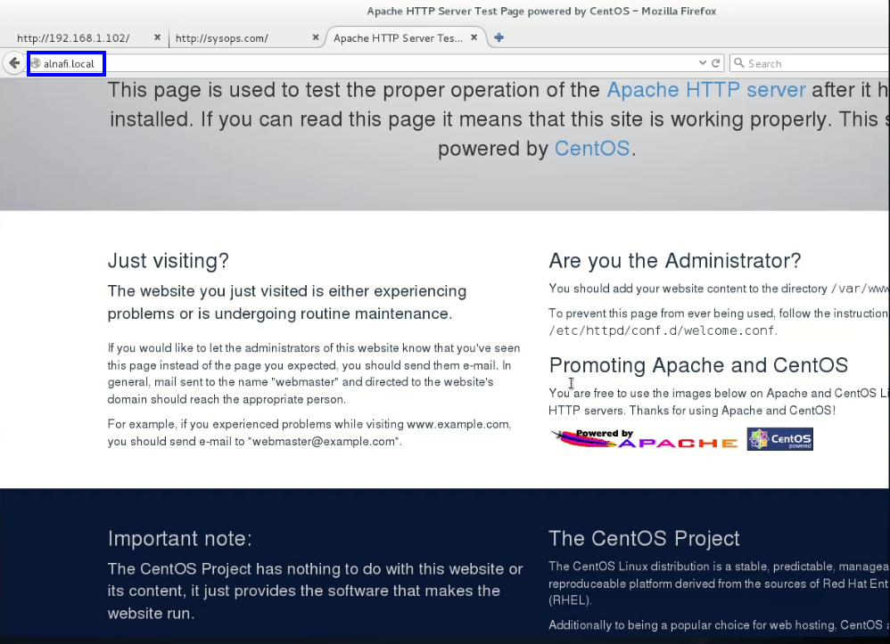
* .
* Everything worked fine until this point,
* 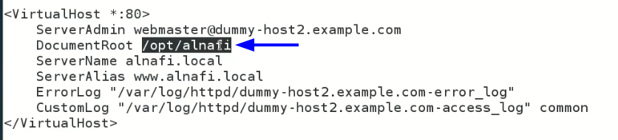
* Instead of displaying the web page from this location 🡪 Apache displayed its default web page.

**Solution???**

* We need to add a **Security Control/root security** in case of multiple website
* 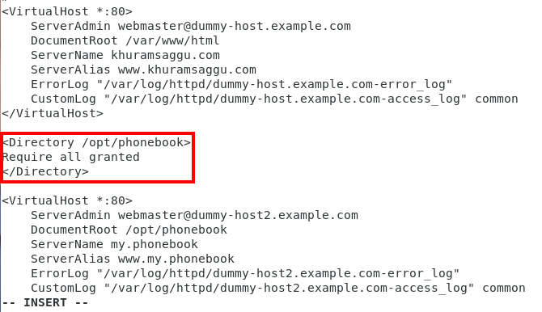
* .
* Sir Kazim added security Control for both containers,
* 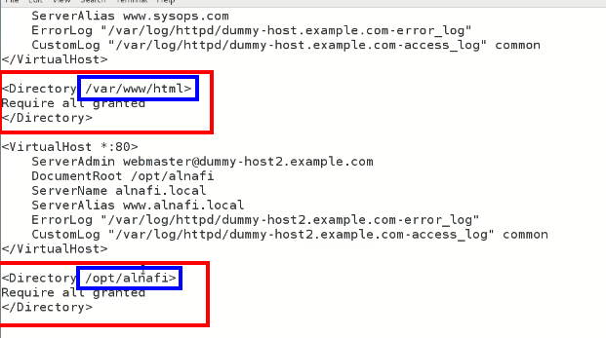.
* Sir Kazim faced issue while attempting to open 2nd web page,
* After analysis he figured out that **SELinux** was enabled on his VM and it was creating issue. He disabled it and the job was done.
* While, it was disabled on my machine that’s why I was abled to open both webpages,
* .
* 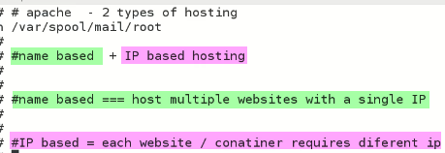.
* .

**DNA**

* These 2 servers are worth learning
* 
* /etc/hosts 🡪 it is not used in organizations 🡪 **DNS** is used instead
* 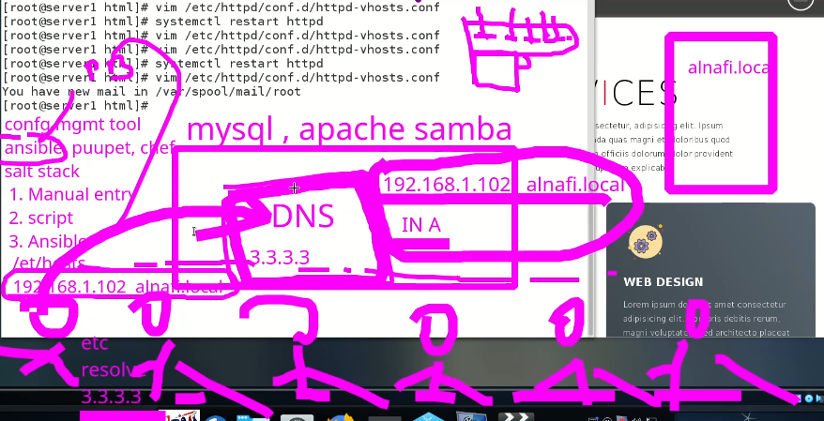
* .
* DNS package in Linux is called “***bind***”.
* .
* .
* First I set the domain name as [www.my.phonebook](http://www.my.phonebook) 🡪 it didn’t work
* Then I renamed it to 🡪 phone.book 🡪 and **it worked.**
* . 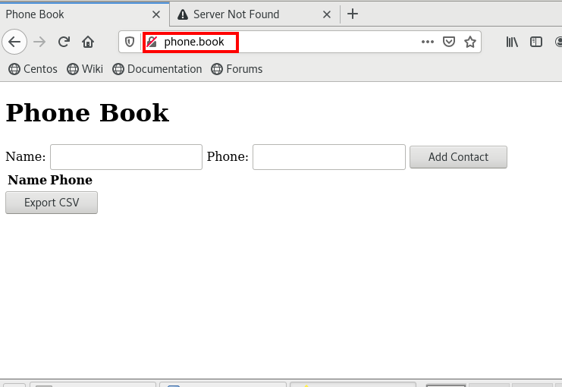
* Now both websites are working side by side
* 